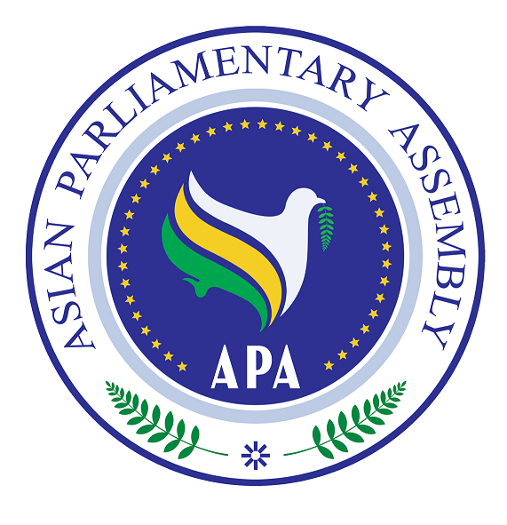

Statement by H.E. Dr. Mohammad Hadi Nejad Hosseinian,
Secretary-General of the Asian Parliamentary Assembly (APA)
At the
Second APA Troika Plus Meeting
On
Israeli Atrocities Against Palestinian People
Tehran, 1 June 2010
Mr. President,
Mr. Speakers,
Honorable Delegates,

Doing the right thing often takes humanity and confidence. It is the right thing for APA Troika Plus to meet here today to address this topic. It involves extreme qualities of human beings over a span of more than 60 years: subjugation, murder, destruction and careless dehumanization on the one hand and resistance, sacrifice, tolerance, loyalty to the cause and hope to make changes for the betterment of life of an entire nation, on the other.

I thank you Mr. President, Honorable, Dr. Marzuki Alie, Mr. Speakers, Honrable Dr. Ali Larijani, Honorable, Mr. Mahmoud Al-Abrash, and Deputy Speaker, Honorable Mr. Tayseer Qubba for assembling here today to pronounce yourself, on behalf of the people of Asia, on the atrocities being committed by the occupying regime not only against the culture, civilizational heritage and against the very life of Palestinian people as a nation, but also against the life of innocent nationals of other states whose crime was to bring humanitarian aid to the besieged people of Gaza. And to do that with impunity.

I shall not fail to register how thankful I and the APA Secretariat are to you, Dr. Larijani, and to the Islamic Parliament of the Islamic Republic of Iran for hosting this meeting in the premises of the parliament and in this historic and beautiful hall.

The brutal and unjustified attack by naval forces of the Zionist regime, yesterday, against the un-armed aid flotilla of six ships en route to Gaza, which killed and injured tens of innocent civilians raised an international uproar. Many innocent civilians carrying humanitarian aid to the Palestinian people in Gaza have been taken hostage by the Israeli forces. The attack against unarmed ships and mass murder of innocent civilians coming reportedly from 60 states to carry aid to the people in Gaza grossly violates every conceivable norm of civilized behavior, let alone the provisions of international humanitarian law and other rules of international law. The Israeli decision to attack the ships carrying aid and the attack raises individual criminal responsibility for those involved, and the international community must hold them responsible for their crime.

The unbelievable audacity and the total disregard for human life demonstrated so vividly by officials and forces of the Zionist regime yesterday and today is but a byproduct of the inaction of the major powers in the United Nations Security Council vis-à-vis 60 years of state terrorism, and systematic crimes of all sort by Israel against the very existence of the Palestinian people. We must use all within our power, compel our governments, encourage our people and civil society to speak loud and clear to the United Nations Security Council to do the right thing this time and cause to bring the perpetrators of this dastardly crime to justice.

Mr. President,
Honorable Speakers,
Ladies and Gentlemen,

Asian Parliamentary Assembly is a diverse and burgeoning parliamentary organization. It is a diverse organization- for it includes members whose populations adhere to different religions and cultures and belong to various great civilizations spread out in the largest continent of the earth. APA is also only several years old. However, neither the diversity of the membership, nor the lack of aggregate years of organizational experience and tradition led to APA’s aloofness vis-à-vis the historic victimization of Palestinian people. Thanks to the leadership provided by APA Presidents since the establishment of the organization and thanks to active representation by Delegation from the Palestinian Parliament, APA has always done the right thing and adopted a major resolution in support of the Palestinian people at each and every Plenary meeting. It is important to recognize that these resolutions are all the more important and valuable because of the diversity of our parliamentary organization.

Allow me to put the APA record on the Palestinian issue in perspective. The APA Plenary has adopted several Resolutions on atrocities of the Zionist Regime in Palestine. The last resolution was adopted on 10 December 2009 in which the APA took note of the latest developments on the ground and condemned Israeli war crimes and violations of international humanitarian law.

The initiative of the visit by the APA Troika in February 2009 to countries neighboring Palestine for exploring ways and means of expressing support for the Palestinian people in Gaza was a real indication of the importance that the APA attaches to the issue of Israeli-Palestinian conflict as a major issue of international peace and security.

The APA Sub-Committee on Major Issues of Peace and Security on Wednesday 12 may 2010, was convened in Tehran. The Palestinian issue and crimes committed by the Zionist regime against the defenseless Palestinian People was on top of the agenda of the meeting. In my report to this Committee, I took note of the resolutions adopted earlier by the APA on violations of international humanitarian law by the occupying regime. I had also drawn particular attention to the illegal acts of excavation under the holy Al-Aqsa mosque, illegal confiscation of lands and withdrawal of identity cards from the Palestinian citizens, mass deportation of Palestinians in a futile attempt to alter the character of the City of Al-Quds, the construction of illegal settlements and erection of a racist separation wall by Israel as violations of human rights of the Palestinian people, which give rise to international criminal responsibility by Israeli perpetrators that should not go unpunished. A resolution to that effect was adopted under leadership of the Palestinian delegation headed by Honorable, Mr. Quba’a. This resolution is recommended to the APA Executive Council for adoption at the Fifth Plenary to be held in Damascus.

In consultation with participating delegations in this Troika plus meeting, a draft communiqué is prepared and is being finalized. It takes note of recent development on the ground and condemns Israeli crimes against humanity, war crimes and violation of international humanitarian law. I am confident that with your contribution, the text will reflect, in the strongest terms, the sentiments of the entire Asia on the atrocities being committed by the Israeli regime.

Mr. President,
Distinguished Speakers,

The APA Secretariat is determined to do the right thing under your leadership, and will work to maintain the urgency that this issue deserves on the agenda of the APA.
Thank you, Mr. President.

